CodeLens

I didn't mention it in the video, but you may have noticed that there is some text above my classes and methods that looks like this:

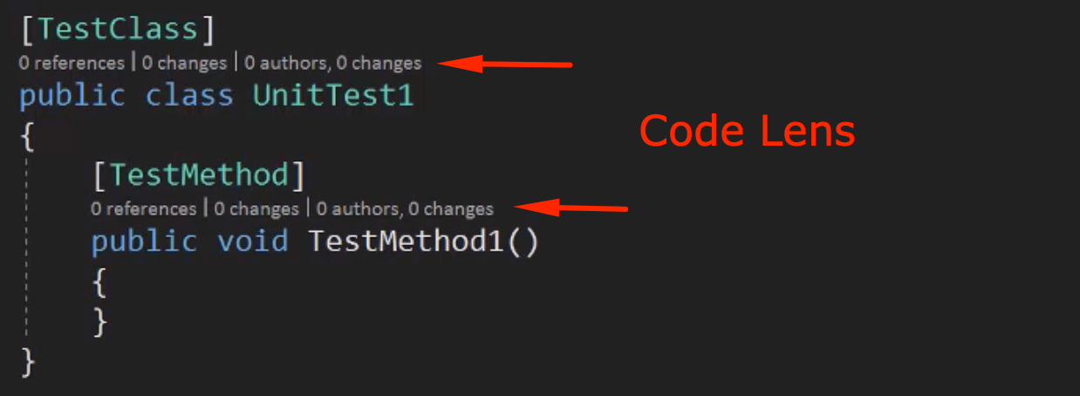

This information is from a Visual Studio Enterprise edition that is called [Code Lens](https://docs.microsoft.com/en-us/visualstudio/ide/find-code-changes-and-other-history-with-codelens?view=vs-2017).

It describes how many other classes are using your method or how many authors have worked on this method and more.

I personally love this feature when working on teams. It becomes extremely useful to track down how a method is being used and if someone altered your method.

I will not cover it in this course because it's only available with Visual Studio Enterprise. However, I did want to make you aware of it :)

PS. [Description] attribute is only valid on test methods. Hope that you weren't confused with my miscommunication.